🩺 Diagnosing Heart Disease Using Machine Learning Explainability

1. Introduction
Machine learning offers powerful tools for predicting heart disease, but clinical applications require more than accuracy — they require trust and interpretability.
This project demonstrates how to make a heart disease model transparent using explainability methods such as Permutation Importance, Partial Dependence Plots (PDP), and SHAP (Shapley Additive Explanations).
The goal is to show how and why the model predicts risk for individual patients, linking machine learning insights with real-world cardiology knowledge.

2. The Data
The dataset is based on the UCI Heart Disease dataset, containing common cardiovascular risk factors and diagnostic indicators.
Feature | Description | Type
age | Age in years | int64
sex | Male/Female | object
chest_pain_type | Type of chest pain (typical angina to asymptomatic) | object
resting_blood_pressure | Resting blood pressure (mm Hg) | int64
cholesterol | Serum cholesterol (mg/dl) | int64
fasting_blood_sugar | >120 mg/dl (Yes/No) | object
rest_ecg | Resting ECG result | object
max_heart_rate_achieved | Maximum heart rate achieved | int64
exercise_induced_angina | Angina during exercise (Yes/No) | object
st_depression | ST depression induced by exercise | float64
st_slope | ST segment slope type (upsloping, flat, downsloping) | object
num_major_vessels | Number of major open coronary vessels (0–4) | int64
thalassemia | Thalassemia type (normal, fixed defect, reversible defect) | object
target | Presence of heart disease (1 = yes, 0 = no) | int64
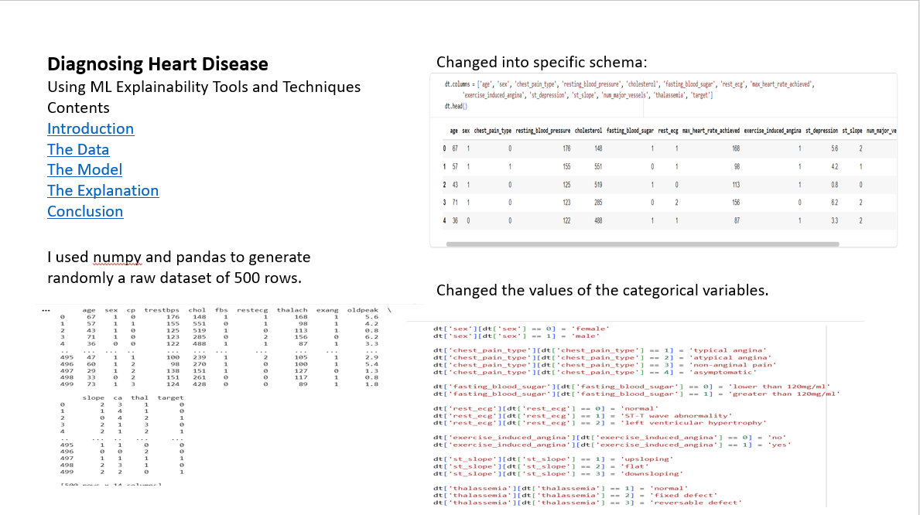

3. The Model
A Random Forest Classifier was trained to predict the likelihood of heart disease based on the above features.
Model performance was evaluated using:
- Accuracy: overall correctness
- Sensitivity (Recall): ability to detect heart disease cases
- Specificity: ability to identify healthy cases
- ROC–AUC: overall model discrimination ability
This ensures the model not only predicts well but can be trusted in a diagnostic context.
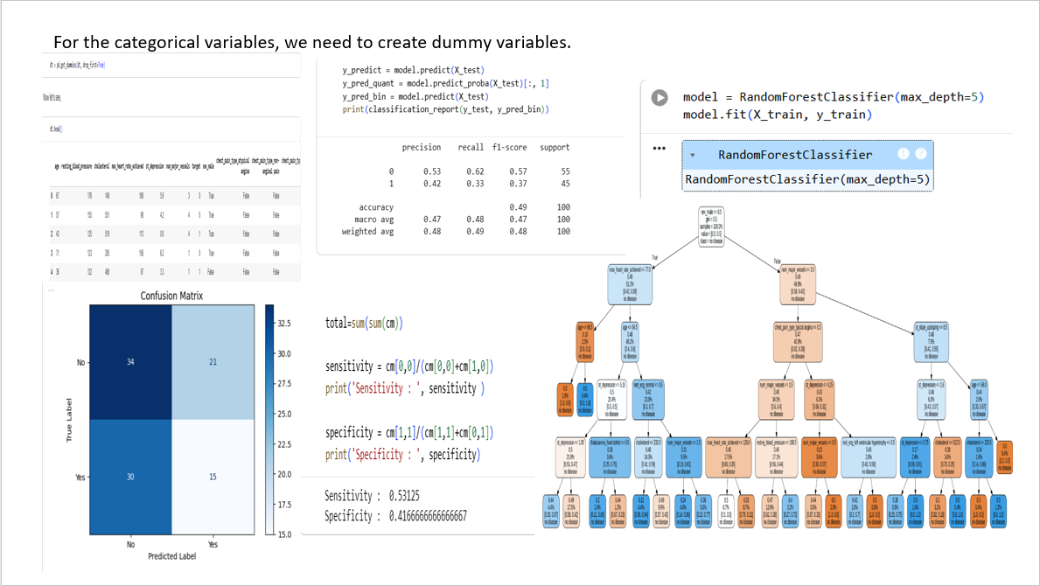

4. Model Explainability
4.1. Permutation Importance
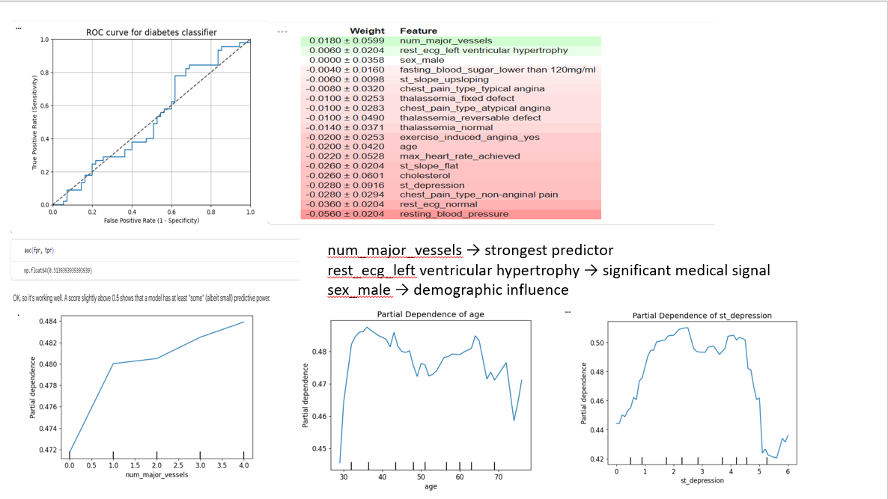
Permutation importance identifies which features the model relies on most by measuring how prediction accuracy drops when each feature is shuffled.
Top predictive features:
- num_major_vessels — the strongest indicator of heart disease.
- rest_ecg_left ventricular hypertrophy — electrical heart abnormality.
- sex_male — demographic risk pattern.
These features align closely with established clinical risk factors.

4.2. Partial Dependence Plots (PDP)
PDPs show how changing one variable influences the model’s output while keeping others constant.
- num_major_vessels:
As the number of open vessels increases, the probability of heart disease decreases.
  - At 0, risk is highest (blocked arteries).
  - At 4, risk is lowest (healthy circulation).
- age:
Risk increases sharply between 30–40 years, then plateaus.
- st_depression:
Moderate to high depression levels correspond to increased disease probability, representing reduced oxygen flow during exercise.

4.3. SHAP (Shapley Additive Explanations)
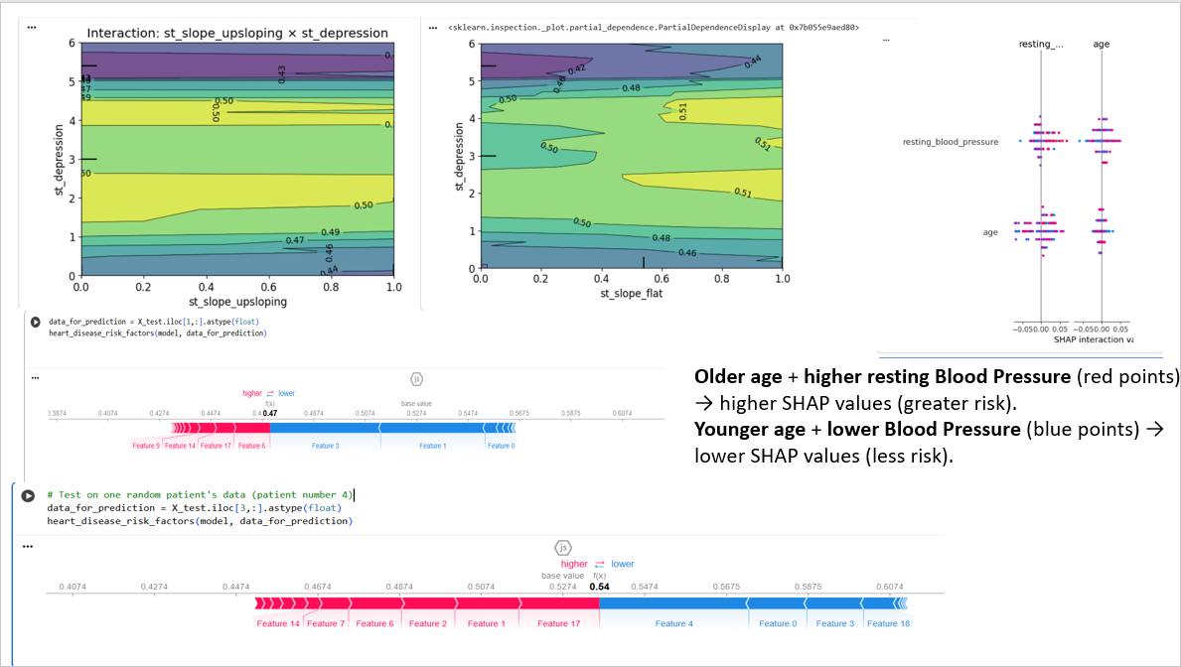
SHAP values assign each feature a contribution (positive or negative) toward a patient’s predicted risk.
Global SHAP summary (bar/beeswarm plots):
- 🔴 Higher values of st_depression, exercise_induced_angina, resting_blood_pressure, and thal_fixed_defect increase heart disease risk.
- 🔵 Higher num_major_vessels, st_slope_upsloping, and thal_normal decrease risk.
These patterns mirror real cardiology relationships between ischemic indicators and heart function.

4.4. Feature Interactions
SHAP interaction plots reveal how two variables jointly affect predictions:
- st_slope_upsloping × st_depression:
Low ST depression with upsloping slope → low risk.
High ST depression → high risk regardless of slope type.
- st_slope_flat × st_depression:
A flat slope combined with moderate ST depression (~3–4 mm) shows elevated risk, reflecting ischemic ECG patterns.
- age × resting_blood_pressure:
Older patients with higher blood pressure show stronger risk amplification.

4.5. Individual Patient Explanations
Using SHAP force and waterfall plots:
Patient A
- Predicted risk: 0.47 (below baseline 0.53)
- Protective factors: multiple open vessels, upsloping ST slope, normal thalassemia.
Patient B
- Predicted risk: 0.54 (above baseline)
- Risk factors: asymptomatic chest pain, fixed thalassemia defect.
- Protective factors: younger age, lower cholesterol.
These local explanations highlight the model’s patient-level reasoning — critical for clinical interpretability.
50 first patients:
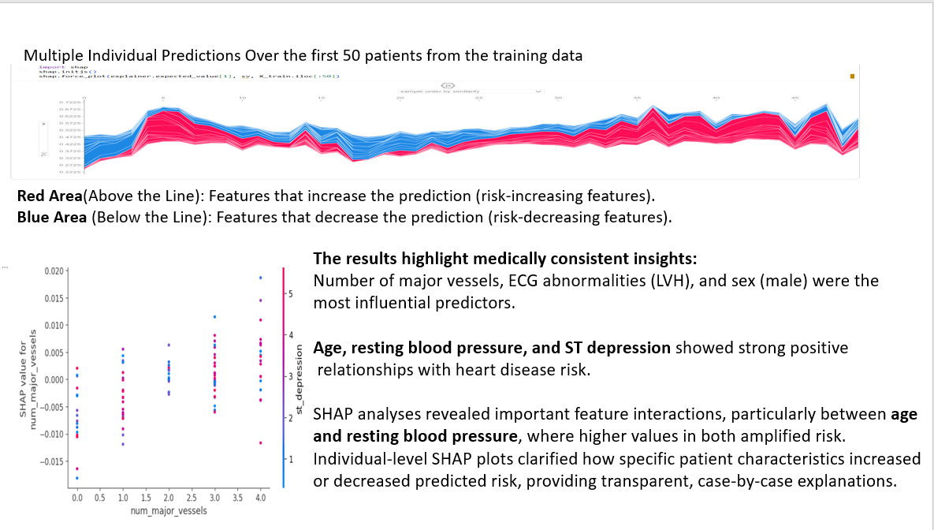

5. Discussion
The explainability results clearly link model behavior to physiological meaning:
Category | Variable | Direction | Clinical Interpretation
Clinical | st_depression, rest_ecg, exang | ↑ Risk | Indicate ischemia or electrical abnormalities
Demographic | age, sex_male | ↑ Risk | Age and gender-related cardiovascular risk
Protective | num_major_vessels, st_slope_upsloping, thal_normal | ↓ Risk | Represent healthy cardiac function
Interactive | st_depression × st_slope, age × BP | Nonlinear | One factor can amplify or override another

6. Conclusion
This project demonstrates how explainable AI can make medical models transparent and clinically relevant.
- The Random Forest model effectively identifies known medical predictors of heart disease.
- Explainability methods (PDP, SHAP) reveal how and why predictions are made.
- The system provides interpretable, trustworthy insights at both global and individual levels.
This project dataset has 500 rows and generated randomly and it could increase the accuracy of the result, which also follows by today's standards. Moreover, it's allowed us to create a simple model and then use various machine learning explainability tools and techniques to peek inside. At the start, I hypothesized, using (Googled) domain knowledge that factors such as cholesterol and age would be major factors in the model. This dataset didn't show that. Instead, the number of major factors, male sex, and aspects of ECG results (LVH) dominated. I actually feel like I've learnt a thing or two about heart disease!
This project demonstrates how machine learning explainability tools can help make black-box medical models more interpretable and trustworthy in diagnosing heart disease. Using a Random Forest classifier on a simulated heart disease dataset, we explored key predictive factors through permutation importance, Partial Dependence Plots (PDPs), and SHAP values.
The results highlight medically consistent insights:
- Number of major vessels, ECG abnormalities (LVH), and sex (male) were the most influential predictors.
- Age, resting blood pressure, and ST depression showed strong positive relationships with heart disease risk.
- SHAP analyses revealed important feature interactions, particularly between age and resting blood pressure, where higher values in both amplified risk.
- Individual-level SHAP plots clarified how specific patient characteristics increased or decreased predicted risk, providing transparent, case-by-case explanations.
- Overall, this approach bridges data science and clinical understanding — showing that interpretable Machine Learning can support medical decision-making by revealing why* a model predicts heart disease risk, not just what it predicts.
- I suspect this sort of approach will become increasingly important as machine learning has a greater and greater role in health care. To invest in preventive care, people's life can be saved and live healthier and longer.
Key Takeaway: Even if genetics or sex cannot be changed, early detection and healthy lifestyle choices significantly reduce heart disease risk.

✅ Final Takeaway:
Combining medical knowledge with explainable machine learning transforms a black-box model into a transparent diagnostic tool that clinicians can understand and trust.

